cg";"rL #

O{–a}lsË ÷P;PdP; ;]jf dfu ;DjGwdf

æPstf ;xeflutf, ldtJoLtf cf:yf ;xsf/Lsf] k|lta4tfÆ

cf:yf jrt tyf C0f ;xsf/L ;+:yf ln=

Aastha Saving and Credit Cooperative Ltd.

ldlt M
>L k|d'v sfo{sf/L clws[t Ho",
cf:yf jrt tyf C0f ;xsf/L ;+:yf ln=
hgsk'/wfd, wg'iff

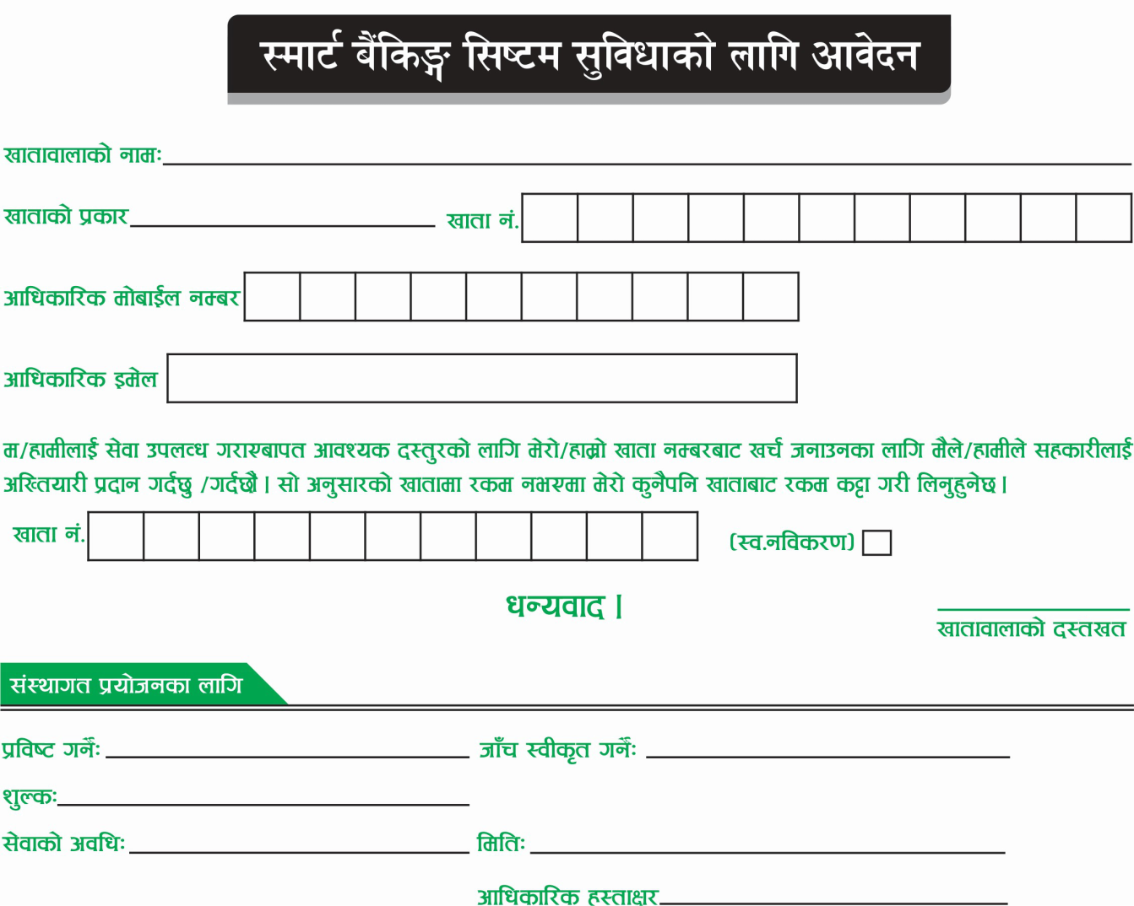

cf:yf jrt tyf C0f ;xsf/L ;+:yf ln= df]afOn a}lsª ;]jfsf lgodx? M

